BibTeX:  
@INPROCEEDINGS{8023530,   
author={H. Dinh and Q. Yuan and I. Vietcheslav and G. Seet},   
booktitle={2017 18th International Conference on Advanced Robotics (ICAR)},   
title={Augmented reality interface for taping robot},   
year={2017},   
volume={},   
number={},   
pages={275-280},   
abstract={Applying masking tape to a particular area is a very important step for protecting an uninvolved surface in processes like mechanical part repairing or surface protection. In the past, the task was very time-consuming and required a lot of manual works. In recent years, with some advances in the fields of automatic robotic system and computer vision, the task now can be completed with the help of an automatic taping system containing a 3D scanner, a manipulator and a rotating platform. This implementation has been proved to provide better quality and be at least twice as fast as comparing to the work done by a human operator. However, there are still some limitations of this setup. First, it is difficult for the user to monitor the taping process since the system uses the 3D scanner to reconstruct the surface model and there is no calibrated projector to overlay the manipulator's trajectory over the real surface. Second, the main user is supposed to use a computer with keyboard and mouse to identify the area for masking which requires some expert knowledge and might not be appropriate in an industrial context where people wear protective equipment such as gloves or helmet. This paper introduces the use of spatial augmented reality technology and wearable device in the semi-automatic taping robotic system and the related calibration algorithms to enhance the user experience. The framework and its components are presented, with a case study and some results.},   
keywords={augmented reality;manipulators;3D scanner;augmented reality interface;automatic robotic system;computer vision;manipulator;rotating platform;semi-automatic taping robotic system;taping robot;Handheld computers;Laser beams;Robot sensing systems;Service robots;Surface treatment;Three-dimensional displays;Human-Robot Interaction;Laser Writer;Taping System},   
doi={10.1109/ICAR.2017.8023530},   
ISSN={},   
month={July},}

**Bibliography**

The current paper introduces the use of spatial augmented reality technology and wearable device in the semi-automatic taping robotic system and the related calibration algorithms to enhance the user experience. The framework and its components are presented, with a case study and some results.

Previously, before the 3D world marked success, applying masking tape to a particular area the task was very time-consuming and required a lot of manual works. In recent years, with some advances in the fields of automatic robotic system and computer vision, the task now can be completed with the help of an automatic taping system containing a 3D scanner, a manipulator and a rotating platform. This implementation has been proved to provide better quality and be at least twice as fast as comparing to the work done by a human operator.

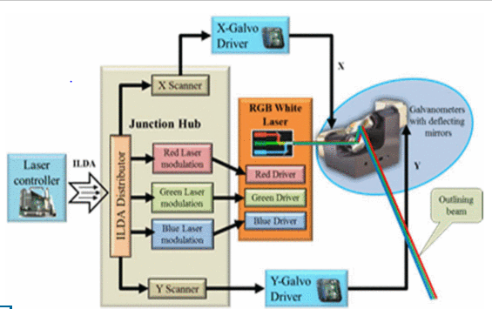

**References:**

* <http://ieeexplore.ieee.org.libproxy.uml.edu/document/8023530/citations>
* <http://ieeexplore.ieee.org.libproxy.uml.edu/document/100007/>
* M. R. Marner R. T. Smith J. A. Walsh B. H. Thomas "Spatial User Interfaces for Large-Scale Projector-Based Augmented Reality" <em>IEEE Computer Graphics and Applications</em> vol. 34 no. 6 pp. 74-82 Nov.–Dec. 2014.
* R. S. Andersen S. Bøgh T. B. Moeslund O. Madsen "Intuitive task programming of stud welding robots for ship construction" <em>2015 IEEE International Conference on Industrial Technology (ICIT)</em> pp. 3302-3307 2015.

"This is entirely my own work, except as disclosed in the documentation. I gave help to the following persons:  
None  
Signed Kiran C Shettar"